Pebble Meditation: A Mindfulness Activity to Cultivate Peace
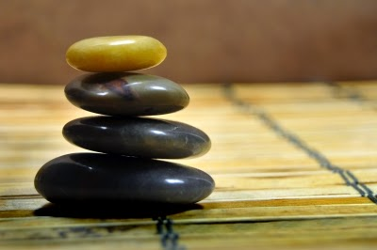
Carlos Porto for freedigitalphotos.net

“Pebble Meditation” is a sample activity from the book Teach, Breathe, Learn: Mindfulness in and out of the Classroom, and is reprinted here with permission from publisher Parallax Press.
http://www.mindfulteachers.org/2014/09/pebble-meditation-mindfulness-activity.html

When I share “pebble meditation” with children in the classroom, I sometimes refer to it as “pebble reflection.” Some of my students also started calling the activity “peace rocks.”
Through mindful breathing and visualization, the qualities of freshness, solidity, clarity, and freedom are cultivated using the images of a flower, a mountain, still water, and a spacious blue sky. The pebbles help us make what can be abstract concepts into something more concrete.
Each student is given a small bag and four pebbles. (You could also have students bring their own pebbles and/or make their own bags.)
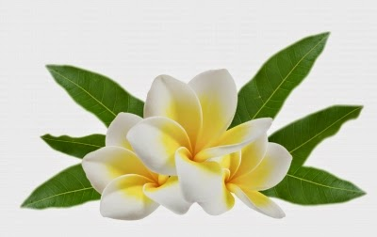
Rakratchada Torsap for freedigitalphotos.net

For the first pebble, the image is a flower and the quality is freshness. Thich Nhat Hanh often talks about how we are all beautiful flowers in a garden of humanity.

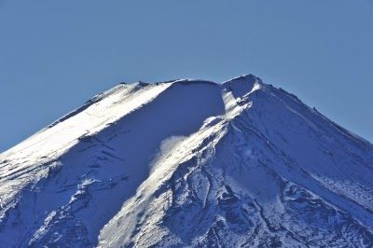
Porbital for freedigitalphotos.net
For the second pebble, the image is a mountain and the quality we are exploring is solidity. The mountain knows it’s solid no matter what is going on around it.
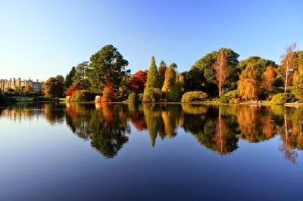
James Barker for freedigitalphotos.net
For the third pebble, the image we are working with is still water in a lake, and the quality we are focusing on is clarity. When we are calm, we can make better decisions.
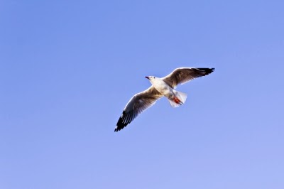
tungphoto for freedigitalphotos.net

The image for the fourth pebble is the spacious blue sky, and the quality is freedom, feeling free from worry or anxiety.
The purpose of this lesson is to teach students practical strategies to help them cultivate peacefulness within so they can be peaceful in the world.
Adapted from Teach, Breathe, Learn: Mindfulness in and out of the Classroom by Meena Srinivasan. Reprinted with permission of Parallax Press, Berkeley, California. www.parallax.org

